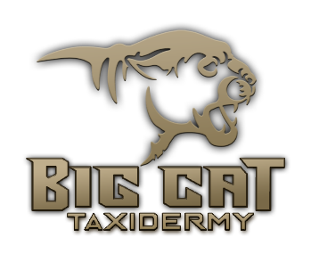

51 Country Lane
Craig, CO 81625
www.bigcattaxidermy.com
jreinier@zirkel.us
970-824-9624

Outfitter:__________________________
Your name________________________________________ Phone # __________________
Address:________________________________________
_________________________________________________
_________________________________________________
_________________________________________________
Email:________________________

Animal:______________________

Pose Description/Instructions:
___________________________________________________________________
___________________________________________________________________
___________________________________________________________________

Information about deposits.....

Deposits are the basis of our funding system. They cover initial expenses that
otherwise come out of our own pocket.
In order to insure your mount is completed in a timely manner, a deposit is needed
on your work order. If a deposit is not received, no work will be performed until the
required deposit amount (50%) is paid. NO work will be accepted into the production schedule until the 50% deposit is paid. Deposits are non-refundable.

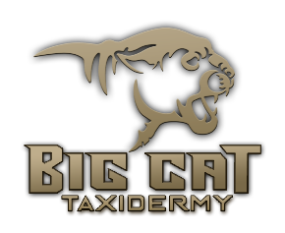

Credit Card Authorization
I understand & agree to pay the amount charged to my credit card which will
be reflected on my credit card statement. The uncontested authorized charge
is based on invoices by: Big Cat Taxidermy, Inc.
O Amex |  | O MasterCard | O Visa | O Discover

Amount:$_____________ Security Code _________
Card Number: ______________________________ Exp Date: _________
Card Holder Name as Printed on Card: _______________________________
Card Billing Address: _________________________________________
___________________________________________________________________
Authorizing Signature: __________________________________________

